Barcode Scanner

Thursday, April 22, 2021

7:53 PM

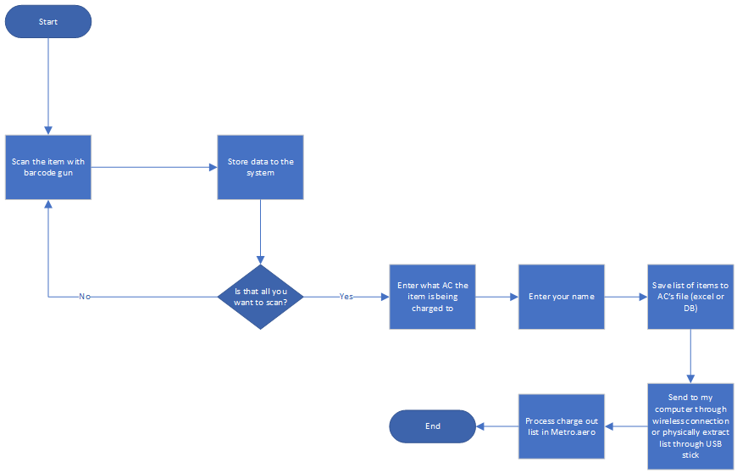

The idea I have is to create a computer that will be in the office that will replace the red book. Instead of everyone writing down every item they charge out, they scan the item, select what AC it is for, and can sign their name. I think I can create system that hold all this data and then forward all this data to my computer to be processed later.

First someone scans an item, then is asked if there are more items, if there are more, then we will save the last item to a list, and then prompt the user for another item. Once there are no more items to be scanned, then we ask the user to enter their name and what AC the items are going to. Then the program will save this data in an excel sheet or database so I can retrieve this later. Then the program will send this data to me through email, or store it to my device through some kind of connection. If I can't automate this part, I can always store this info on a USB drive so I can drag and drop the files to my computer later. Then I process the list in metro.aero.

This process could help reduce the redundancy and time it takes for mechanics to grab the parts they need and will keep everything electronically signed, so it also eliminates human errors like bad hand writing. It also organizes and reduces clutter. As we all know having a huge binder full of paper, things get over looked and lost. I would clean the USB drive or device every time I process the checked out parts and keep the old records on my computer.

Problems that could arise is dealing with serialized items. I'll have to maybe add another prompt to ask if this item has a serial number, or I can always make it an option. Also the cost could slow me down as well. Though I think I can get this done fairly cheap using amazon.